AutoConnect

**FYP– I REPORT**

**BS(CS) Fall 2023**

Name: IshaqUllah Siddiqui

20k-0148

Name: Syed Muhib Ahmed

20k-0405

Name: Sarim Latif Khan

20k-1644



**Supervisor: Ubaid Aftab Chawala**

**Department of Computer Science**

**FAST-National University of Computer & Emerging Sciences, Karachi**

Contents

Introduction 3

1. Related Work 3
2. Methodology 3
3. Testing and Results 4
4. System Diagram 5
5. Goals For FYP-II 5
6. Conclusion 8

# Introduction

Our groundbreaking e-commerce platform is dedicated to revolutionizing the vehicle commerce landscape by addressing the inefficiencies and complexities prevalent in current transactions. Tailored specifically to the automotive industry, our solution aims to bridge the gap between buyers and sellers, offering unparalleled convenience, transparency, and efficiency. In a diverse market with unique needs, traditional methods often fall short, prompting the need for a platform that empowers users with tools and information for informed decision-making. Our project's significance lies in its potential to transform the vehicle commerce experience through innovative features such as the Smart Negotiation Bot, Live Video Calling, and AI-Driven Recommendations. Seamlessly blending technology with human expertise, our user-centric platform not only streamlines transactions but fosters meaningful interactions, creating a community where knowledge and passion converge. By choosing our platform, users opt for innovation, transparency, and a revolutionary shift in the world of vehicle commerce.

# Related Work / (SRS/SDS)

This section outlines the systematic blueprint for the "AutoConnect" platform, encapsulating the System Requirements Specification (SRS) and System Design Specification (SDS). The SRS elucidates the functional and non-functional requirements, providing a detailed understanding of what the system is expected to achieve. On the other hand, the SDS delineates the architectural and design aspects of the system, mapping out how these requirements will be realized. Together, these documents serve as the cornerstone for the development phase, guiding the project toward its intended goals and ensuring alignment with user expectations and market demands.

# Methodology

In this section, we outline the research methods and techniques that will guide the development of our car buying and selling web application. We justify the choice of our methodology and discuss its appropriateness for achieving the project's objectives. Additionally, we provide insights into data collection, analysis, and the tools and software that will be employed throughout the project.

**Research Methods and Techniques:**

**User-Centered Design:** Our project will prioritize user-centered design, ensuring that the car buying and selling web application is intuitive and aligned with generalized user habits. By conducting surveys, interviews, and usability testing, we aim to gain valuable insights into how users typically interact with online marketplaces and what features and functionalities resonate with them. This approach allows us to create a user interface that feels familiar and user-friendly, enhancing the overall user experience. Our design decisions will be guided by a deep understanding of how users navigate similar platforms, ultimately resulting in a more accessible and engaging application.

**Prototyping:** Prototyping is a practical approach for visualizing the user interface and functionality early in development. It mitigates the risk of costly design changes later in the project and supports our user-centric design approach.

**Data Collection:** Data for the recommendation engine will be gathered from user interactions on the platform, including search queries, user profiles, and vehicle preferences. Additionally, external data sources, such as vehicle history reports, will be integrated.

**Data Analysis:** Data analysis involves preprocessing, cleaning, and transforming data for machine learning. Feature engineering will enhance the recommendation algorithm's effectiveness.

**Tools and Software:**

Our toolkit will encompass various tools and software components;

**Database:** Postgresql for data storage.

**Front-end development:** React, MUI and React Router.

**Back-end development:** .NET and Entity Framework.

**Chatbot Server:** Dialogue Flow by Google and Node JS for Web hooks.

1. Testing and Results

1. **User Interface Testing:**

• **Navigation Testing:** Ensured smooth navigation through the Web app, covering all the navigation possibilities.

• **Responsiveness Testing:** Checked the Web app's responsiveness across various devices and orientations, addressing layout discrepancies.

• **Visual Aesthetics and Consistency:** Scrutinized color schemes, typography, and icons for consistency, ensuring a visually appealing interface.

1. **User Experience Testing:**

• **Usability Testing:** Evaluated how easily users could perform actions like posting an ad, view vehicle listings and personal ads, refining the app's layout based on feedback.

• **Feedback and Iterative Improvements:** Incorporated user feedback throughout testing, contributing to continuous enhancements in usability and overall user experience.

1. System Diagram

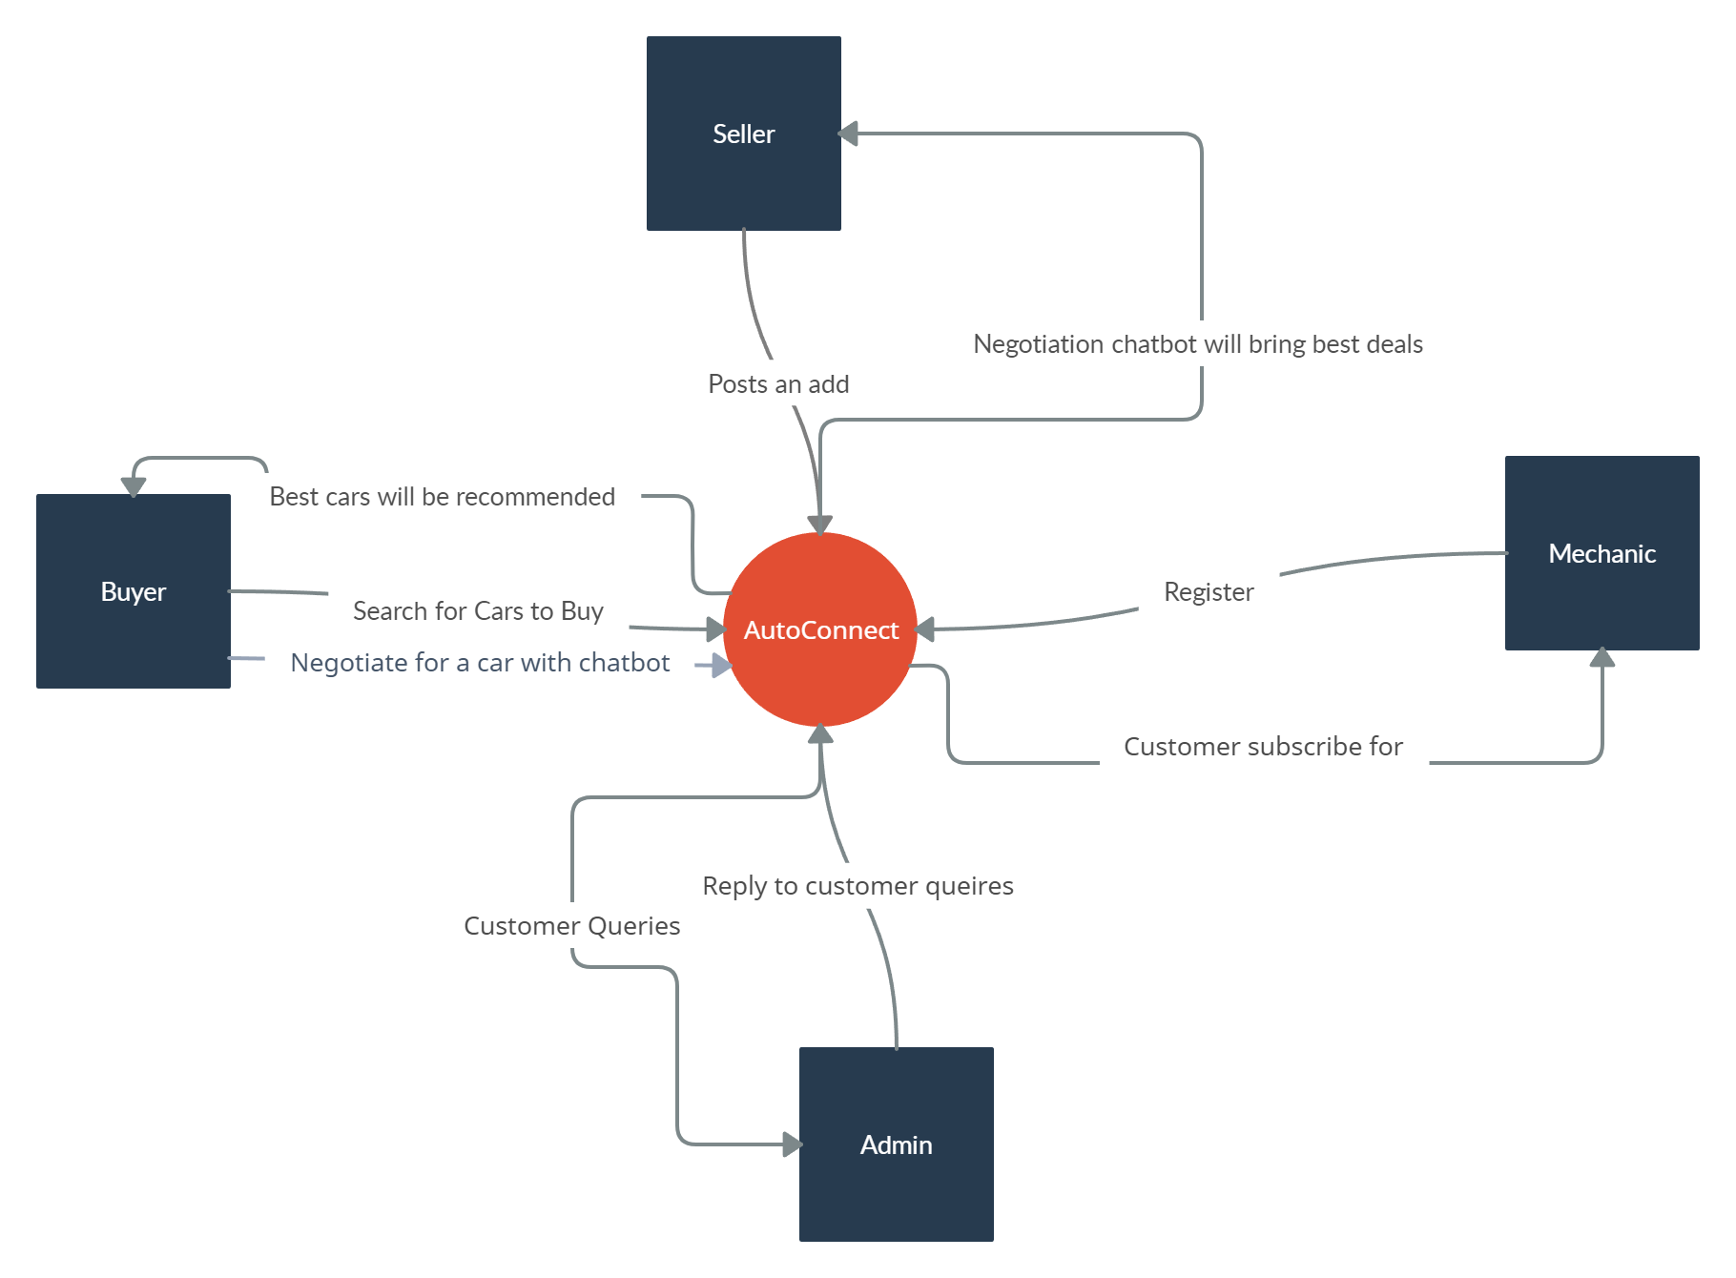

1. Goals For FYP-II

**Advanced Search and Filters:**

The "AutoConnect" platform incorporates an Advanced Search and Filters feature to empower users with precision and efficiency in navigating the diverse array of vehicles. This feature enables users, including buyers, sellers, mechanics, and administrators, to refine their searches based on specific criteria such as make, model, year, price range, mileage, and more. By providing an intuitive and customizable filtering system, users can quickly narrow down their options, ensuring a streamlined and targeted search experience. This advanced functionality not only enhances user satisfaction but also contributes to the platform's overall effectiveness by facilitating quicker and more accurate matches between buyers and sellers. It caters to the diverse needs of users within the automotive ecosystem, providing a tailored and user-friendly approach to vehicle discovery.

**Portals for Mechanic, Buyer, Seller, and Admin:**

The "AutoConnect" platform is designed with distinct portals catering to the varied roles within the automotive ecosystem.

- **Mechanic Portal:**

- Mechanics have a specialized portal where they can offer services, view relevant vehicle information, and engage with users needing their expertise.

- Access to diagnostic data and maintenance history allows mechanics to provide informed recommendations and services.

- Seamless communication channels enable mechanics to connect with both buyers and sellers for inspections and consultations.

- **Buyer Portal:**

- Buyers benefit from a personalized dashboard showcasing recommended vehicles based on preferences and search history.

- Advanced search and filter options empower buyers to refine their choices and make informed decisions.

- Integration with the Live-Video Calling feature enables virtual inspections and direct communication with sellers.

- **Seller Portal:**

- Sellers have a dedicated portal to manage and showcase their vehicle listings with detailed information, images, and pricing.

- Access to AI-Driven Recommendations aids sellers in optimizing their listings for better visibility and engagement.

- Direct communication channels, including the Live-Video Calling feature, facilitate interactions with potential buyers.

- **Admin Portal:**

- Administrators have a centralized dashboard to oversee and manage the entire platform.

- Monitoring user activity, resolving disputes, and ensuring compliance with platform policies are integral functions.

- Analytics tools provide insights into user behavior, helping administrators make data-driven decisions for platform enhancements.

These specialized portals cater to the unique needs of each user category, fostering a seamless and tailored experience for mechanics, buyers, sellers, and administrators within the "AutoConnect" platform.

**Live-Video Calling Feature:**

The Live-Video Calling feature of the "AutoConnect" platform is designed to elevate the user experience by introducing real-time, interactive communication between buyers and sellers. This feature enables users to engage in virtual face-to-face discussions, inspecting vehicles remotely, and addressing queries instantaneously. Leveraging this functionality, buyers can gain a more comprehensive understanding of the vehicle's condition, features, and overall appeal, fostering trust and transparency in the transaction process. Sellers, in turn, can showcase their vehicles dynamically, addressing potential concerns and building a more personal connection with prospective buyers. The Live-Video Calling feature not only transcends geographical constraints but also enhances the overall efficiency of the buying and selling process, making it a pivotal component in redefining the landscape of automotive e-commerce.

**AI-Driven Recommendations:**

The AI-Driven Recommendations feature of the "AutoConnect" platform introduces a sophisticated layer of intelligence to the user experience. Powered by advanced algorithms, this feature analyzes user preferences, historical data, and market trends to deliver personalized and relevant recommendations. For buyers, the system suggests vehicles based on their preferences, budget, and past interactions, streamlining the search process and ensuring a tailored browsing experience. Sellers benefit from AI-driven insights, receiving recommendations on optimizing listing details, pricing strategies, and potential target audiences. This intelligent recommendation system not only enhances user satisfaction but also contributes to the efficiency of the platform by facilitating quicker and more informed decision-making. By integrating artificial intelligence into the recommendation process, the platform aspires to be at the forefront of innovation in the automotive e-commerce sector, offering users a uniquely curated and intelligent marketplace experience.

**Review and Feedback Mechanism:**

The "AutoConnect" platform places a significant emphasis on user engagement and satisfaction through its robust review and feedback mechanism. This feature allows buyers and sellers to share their transaction experiences, fostering transparency and accountability within the platform. Users can assign scores through a comprehensive rating system, offering a quick visual reference for assessing the credibility and reliability of sellers and service providers. Structured feedback forms cater to specific interactions, such as Live-Video Calls and mechanic services, encouraging users to provide detailed insights for continuous improvement. In-app surveys, conducted periodically, solicit opinions on the platform's features, usability, and overall satisfaction, serving as valuable tools for identifying areas of enhancement. Real-time notifications ensure users stay informed about new reviews, fostering a responsive feedback loop and timely addressing of concerns. Leveraging analytics tools, the platform analyzes aggregated feedback data to identify trends and areas for improvement, driving data-driven decision-making. The platform's commitment to a resolution mechanism in case of disputes demonstrates its dedication to user satisfaction and platform integrity. Overall, this holistic review and feedback mechanism not only promotes trust among users but positions the "AutoConnect" platform for continual refinement and growth based on real user experiences and evolving industry trends.

1. Conclusion

In conclusion, the successful completion of the initial development phase for our "AutoConnect" web app, including the seamless integration of the chatbot, signifies a crucial milestone in our final year project. Progress has been swift, and the platform is now fully operational. The focus now shifts to implementing key features such as advanced search and filters, live video calling, AI-driven recommendations, and a comprehensive review mechanism. These features, designed to enhance user experience and address market challenges, represent the next phase of our project. Our commitment to staying at the forefront of technological innovation and reshaping the vehicle commerce landscape in Pakistan remains unwavering. With development progressing at an accelerated pace, we are poised to deliver a trailblazing platform that fosters a community of satisfied and engaged users, marking the culmination of our final year project.

# 